# Lab: JS for Front-End

Problems for exercises and homework for the ["JavaScript Applications Course @ SoftUni"](https://softuni.bg/courses/js-apps).

## Grid System

Create a Web Page like the following:

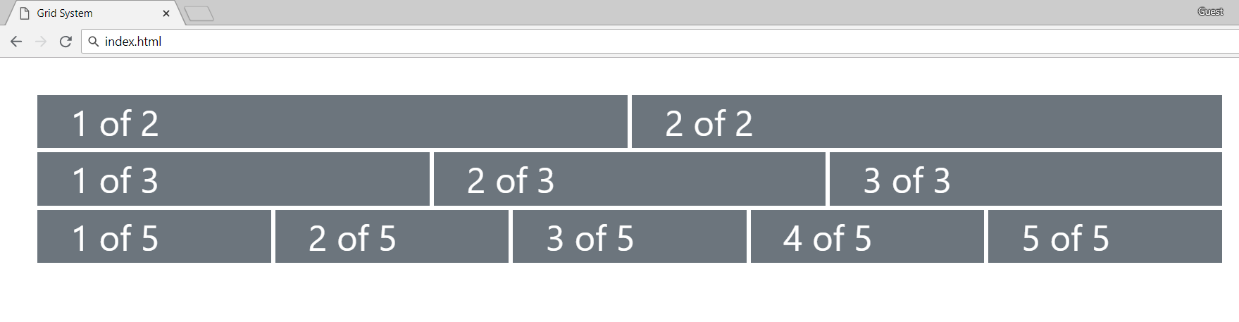

### Hints

* Look at [Bootstrap Grid System documentation](https://getbootstrap.com/docs/4.0/layout/grid/)
* Use class **row** for every line
* Define containers with class **col** inside every row
* Use margin (**m-3**) class for the main container
* Use **bg-secondary** color for every column

## Navigation Bar

Create a Web Page like the following:

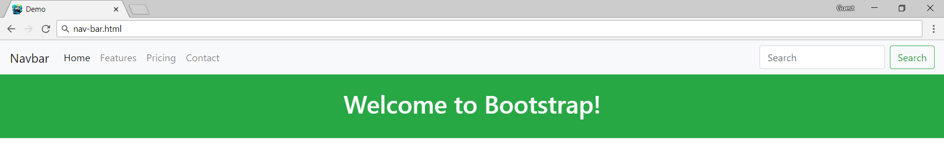

### Hints

* Read about navigation bars at <https://getbootstrap.com/docs/4.0/components/navbar/>
* Use class **navbar**
* Remove default paddings for the navigation (**p-0**)
* Use separate containers for navigation and welcome message

## Table

Create a Web Page that have table with First Name, Last Name and Job Position like the following:

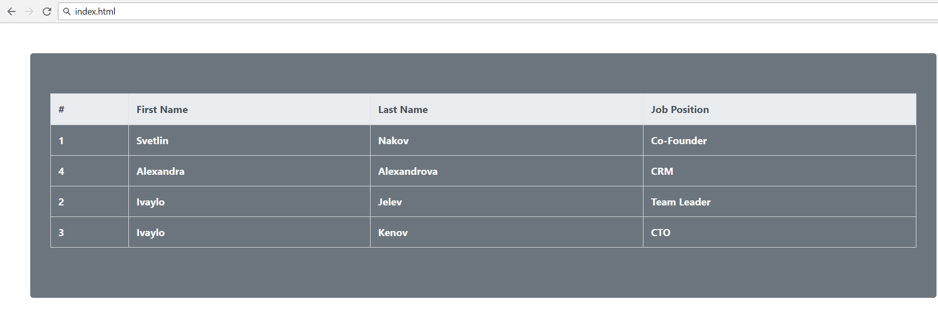

### Hints

* Read about **tables** in **Bootstrap** at <https://getbootstrap.com/docs/4.0/content/tables/>

## Form

Create a Web Page like the following:

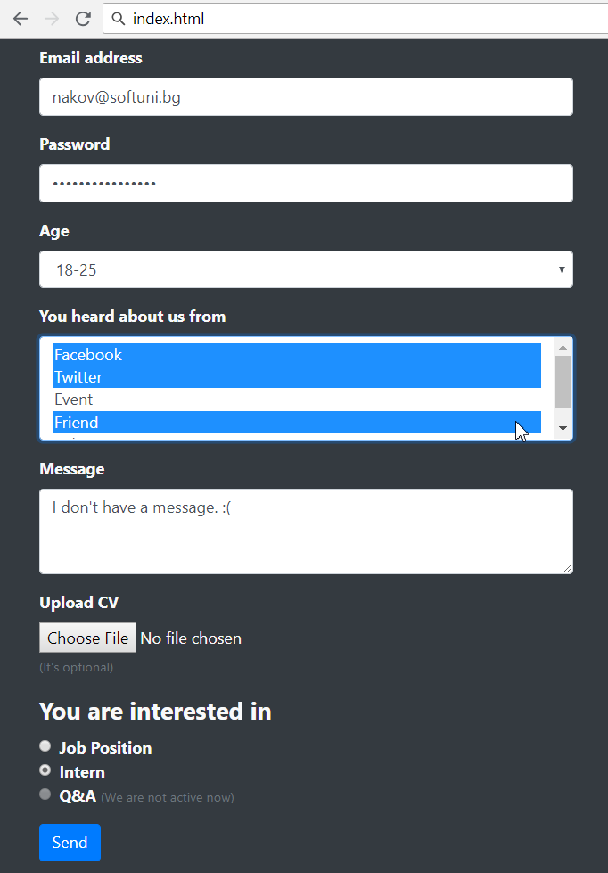

### Hints

* Read about **tables** in **Bootstrap** at <https://getbootstrap.com/docs/4.0/content/tables/>

